Accepting Applicants for Akita International Festival 2015
Date and time： 10：00～16：00 Saturday, Sept. 26, 2015
Venue： Aeon Mall Akita, 1F Central Court
（1-1-1 Goshonojizoden, Akita City）
Organizer： Akita International Association
Goal： To put display booths of other countries and to interact with the many citizens of Akita.
Event content： Booth exhibits（refer to the picture below）
Conditions for applying：
① You must attend one of the pre-event meetings (dates and times below).
※Time：About 30 min.
・Friday, Sept. 4 18：00～
・Saturday, Sept. 5 10：00～
② You cannot make, distribute, or sell and food items at the venue.
③ You cannot use the venue facility’s electricity.
④ You must prepare a quiz about the country you will be introducing.
How to apply： Fill out the application form and submit it by Friday, July 31 to the Akita International Association by mail, fax, or email.
Akita International Festival 2014 (Pictures from last year)

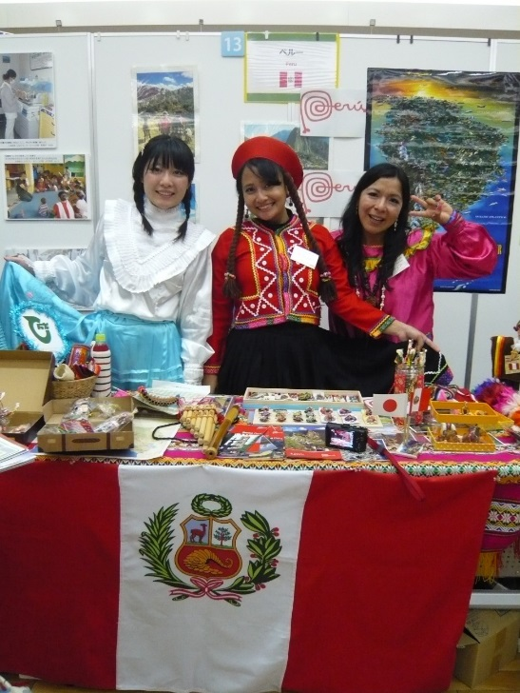


Akita International Festival 2015 Application Form

Deadline | Friday, July 31, 2015
Date of Application

Where to apply：Akita International Association
Atorion 1F, 2-3-8 Nakadori, Akita City 010-0001
FAX：018-825-2566 TEL：018-893-5499
Email: takeishi@aiahome.or.jp

Name of country you will introduce | Japanese：
Name of country you will introduce | English：
Applicant Name
Address | 〒
Contact Information | School Name
Contact Information | Email
Contact Information | TEL
Pre-event meeting  Please check  one | □9/4（Fri）18：00～ 1F Atorion AIA Office  □9/5（Sat）10：00～ 1F Atorion AIA Office

