Information of booth application for Akita International Festival 2023

[Event info]
Date and time： 10：00～16：00, 1st Oct（Sun）, 2023
Venue： Akita Community-based Center 'ALVE'
（4-1,Naka-machi,Higasi-douri,Akita-city,）
Organizer： Akita International Association
Aims： Enhance the understanding of international culture between Akita's citizens and foreign residents through the exhibition and interaction.
Format： Booth（refer to the picture below）
Conditions：
- Organizations should be related to international exchange, multicultural information, and no commercial, religion and political purposes.
- For selling merchandise, please notify us about the merchandise details and the use of profit in advance.
- Attend to one of the pre-event meetings is needed. (date and time below).
15 Sep (Fri) 18：00～ or 16 Sep (Sat) 10：00～
※Duration：About 30 mins.
Fees: Free of charge ※Our Association does not provide any subsidies for the activities.
Fill out the application form and submit to the Akita International Association by postal mail, fax, or email on or before 28 July,2023 (Fri).
Akita International Festival 2022

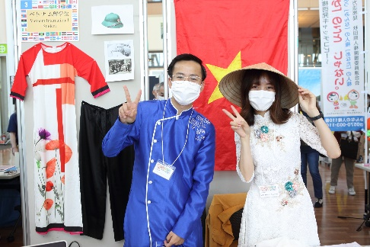

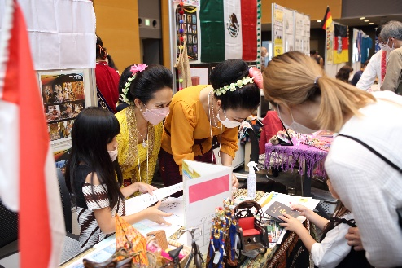

Akita International Festival 2023 Application Form

Deadline | 28 July (Fri), 2023
Date of Application

Where to apply：Akita International Association
Atorion 1F, 2-3-8 Nakadori, Akita City, 010-0001
FAX：018-825-2566 TEL：018-893-5499
Email: monma@aiahome.or.jp
Organization Name  (English name is also required) | Japanese：
 | English：
Applicant Name
Address | 〒
Contact Information | Tel
 | Fax
 | Email
 | Mobile
Exhibition Experience | □New □Past experience
Country you will introduce
Selling Merchandise  ※Please provide the details of merchandise | □Booth exhibition only（no transaction）
□Selling Merchandise
Items・Price：
Use of profit：
Pre-event meeting  Please check one | □15 Sep（Fri）18：00～ 7F Atorion Kurashino-kenshushitsu  □16 Sep（Sat）10：00～ 7F Atorion Kurashino-kenshushitsu

