Information of booth application for Akita International Festival 2025

[Event info]
Date and time： 10：00～16：00, 5th Oct（Sun）, 2025
Venue： Akita Community-based Center 'ALVE'
（4-1,Naka-machi,Higasi-douri,Akita-city,）
Organizer： Akita International Association
Co-hosted by: Japan International Cooperation Agency Tohoku Center (JICA Tohoku)
Number of visitors: 1,190 (FY2024)
Aims： Enhance the understanding of international culture between Akita's citizens and foreign residents through the exhibition and interaction.

[Booth Exhibitor Application Guidelines]
Format： Exhibition Booth ※refer to the picture on the next page
(Booth exhibition only (no transaction), or selling merchandise)
Conditions：
- Organizations should be related to international exchange, multicultural information, and no commercial, religion and political purposes.
- For selling merchandise, please notify us about the merchandise details and the use of profit in advance.
- Attend to one of the pre-event meetings is needed. (date and time below).
19 Sep (Fri) 18：00～ or 20 Sep (Sat) 10：00～
※Duration：About 30 mins.
Fees: Free of charge
※Our Association does not provide any subsidies for the activities.
How to apply: Fill out the application form and submit to the Akita International Association by postal mail, fax, or email on or before 11 July,2025 (Fri).
※In the event that there are a large number of applicants, we may decline your application, as priority will be given to organizations with the most well-rounded exhibition plans listed on the application form. Please be aware of this.

[Other]
- We are looking for 19 different foreign country booths.
- Booth location cannot be specified.
- Preparations will be made on the morning of the event, so please bring your belongings with you to the venue on the day.
- There will be a quiz rally to promote interaction with visitors, so please prepare a quiz to bring.
- AIA will prepare the following equipment at the venue (one set per booth)
・Panel(220cm x 100cm) 2panels * Use by connecting two vertical panels horizontally.
・Long table(180cm x 60cm) Single table
・Chairs(2)
・Tape and thumb tacks for attaching materials
- If you use the parking lot on the day, you will be responsible for any parking fees.
- Please note that any photographs and videos taken on the day of the festival may be used in our association's printed materials and website for the purposes of reporting and introducing our business activities.

Pictures of Akita International Festival 2024
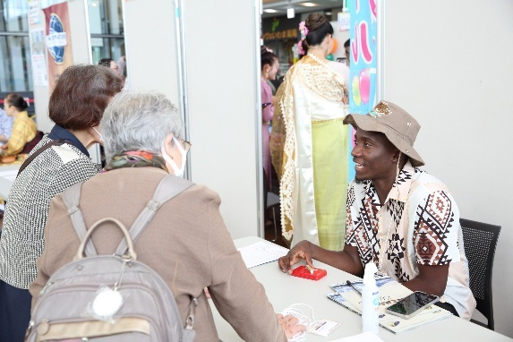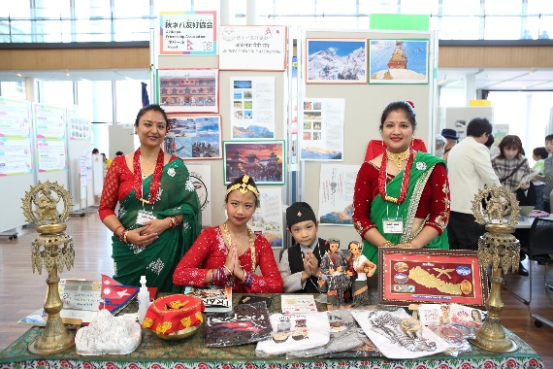
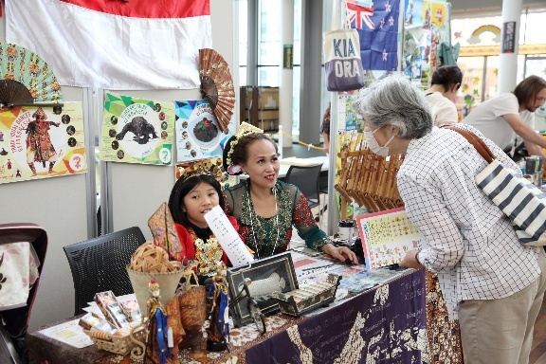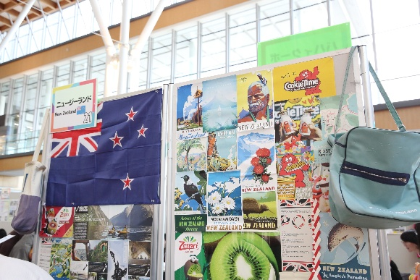

Akita International Festival 2025 Application Form

Deadline | 11 July (Fri), 2025
Date of Application

Where to apply：Akita International Association
Atorion 1F, 2-3-8 Nakadori, Akita City, 010-0001
FAX：018-825-2566 TEL：018-893-5499
Email: aia@aiahome.or.jp
Organization Name  (English name is also required) | Japanese：
 | English：
Applicant Name
Address | 〒
Contact Information | Tel
 | Fax
 | Email
 | Mobile
Exhibition Experience | □New □Past experience
Country you will introduce
Selling Merchandise  ※Please provide the details of merchandise | □Booth exhibition only（no transaction）
□Selling Merchandise
Items・Price：
Use of profit：
Pre-event meeting  Please check one | □19 Sep（Fri）18：00～ Online（Zoom）  □20 Sep（Sat）10：00～ 7F Atorion Kurashino-kenshushitsu

